**JOBSHEET 3**

**Array of Object**



**Name**

Sherly Lutfi Azkiah Sulistyawati

**NIM**

2341720241

**Class**

1I

**Major**

Information Technology

**Study Program**

D4 Informatics Engineering

**Lab Activity 1: Create, insert, and display Array of Object**

**Result**



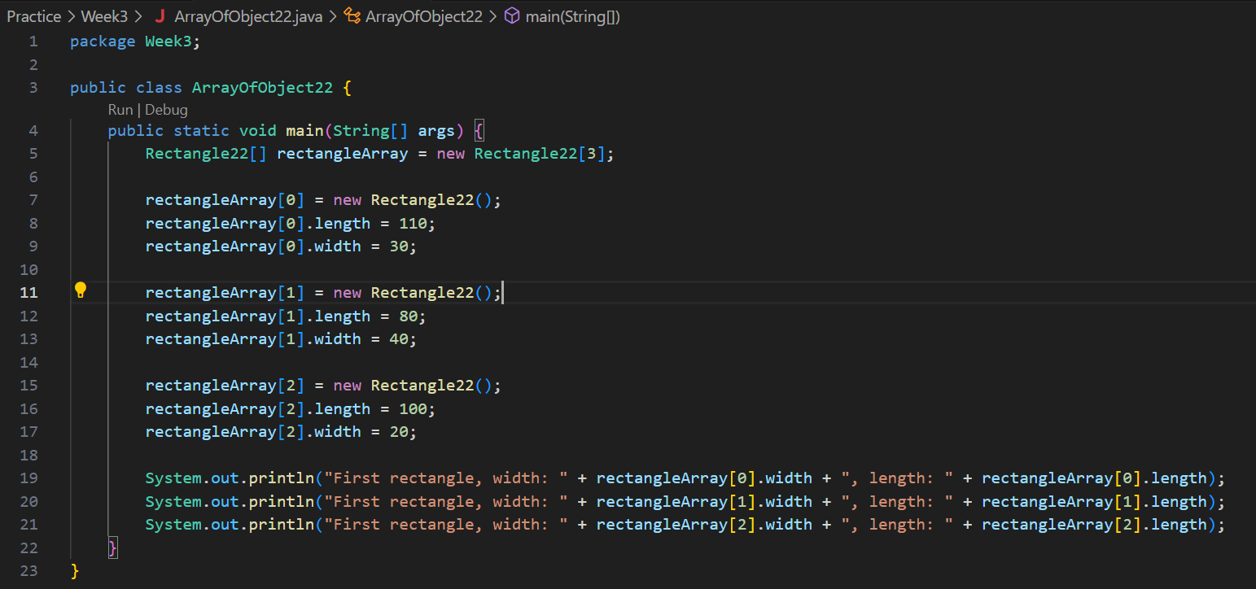



**Question**

1. Based on part 1.2, does the class that are going to be used as an array of object must have attributes and methods? Please explain!

Answer: It doesn’t have to, depends on the condition of the program we create. But, normally the class have attributes and methods. Attributes define the properties of the object, while methods define the behaviour or actions that object can perform.

1. Does class Rectangle have constructor? If not, why we instantiate the object as follows?



Answer: The class Rectangle doesn’t have explicitly define a constructor, that will be define as a default constructor. So, when we instantiate the object like the example, it calls the default constructor.

1. What’s the meaning of this line of code?



Answer: That line of code Rectangle[] declares rectangleArray as an array that can hold objects of type Rectangle. rectangleArray = new Rectangle[3] initialize rectangleArray to have a length of 3.

1. What’s the meaning of these lines of code?

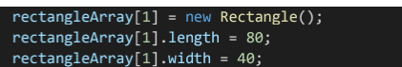

Answer: We instantiate a new Rectangle object at index 1 and set the attributes (length and width) of the Rectangle object at index 1 in rectangleArray.

1. Why ArrayOfObject class and Rectangle class should be separated?

Answer: Separating classes help us to organized code. Each class should have a single responsibility. ArrayOfObject class is likely to manage the array and its manipulation, while Rectangle class represents the concept of a rectangle with its own attributes and methods.

**Lab Activity 2: Input data into Array of Objects using Loops**

**Result**

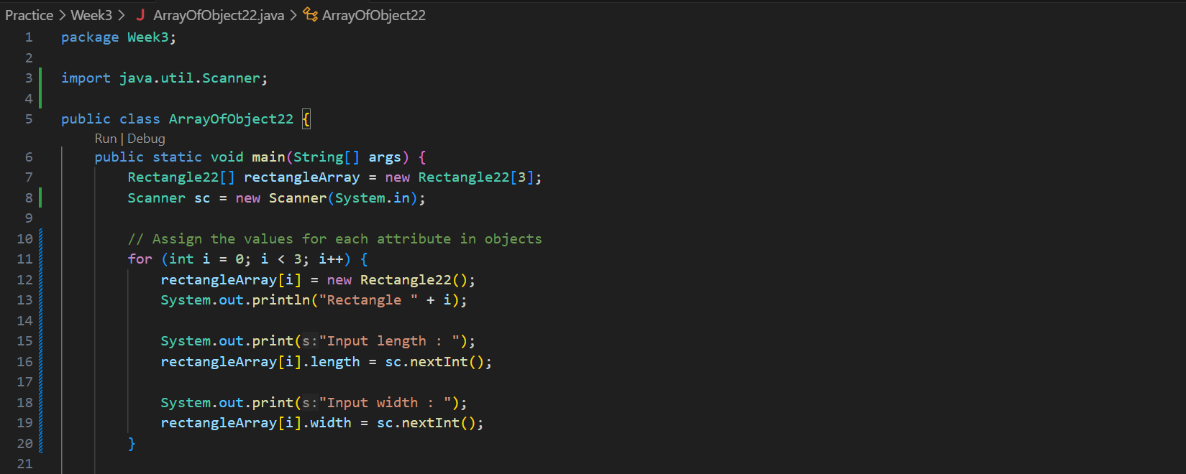

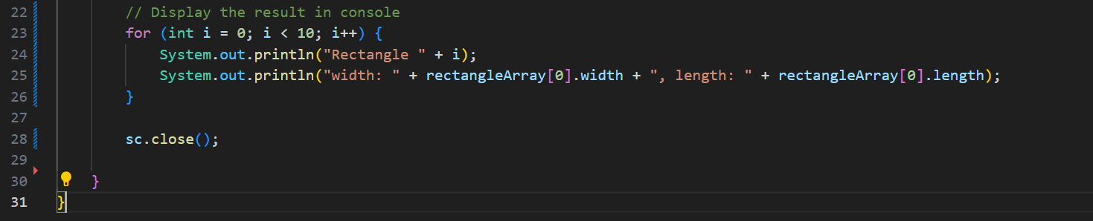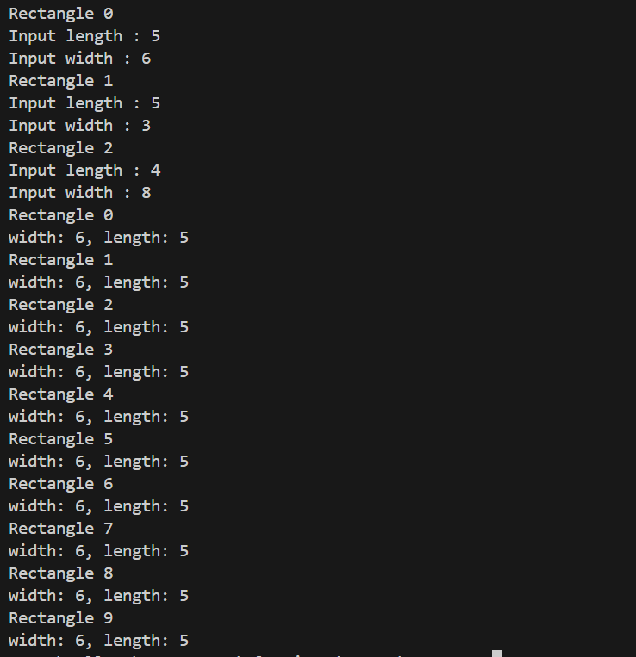

**Question**

1. Does array of object can be implemented on 2D array?

Answer: Yes, it does. Array of object can be implemented on 2D array.

1. If yes, then please give an example. Otherwise, please explain.

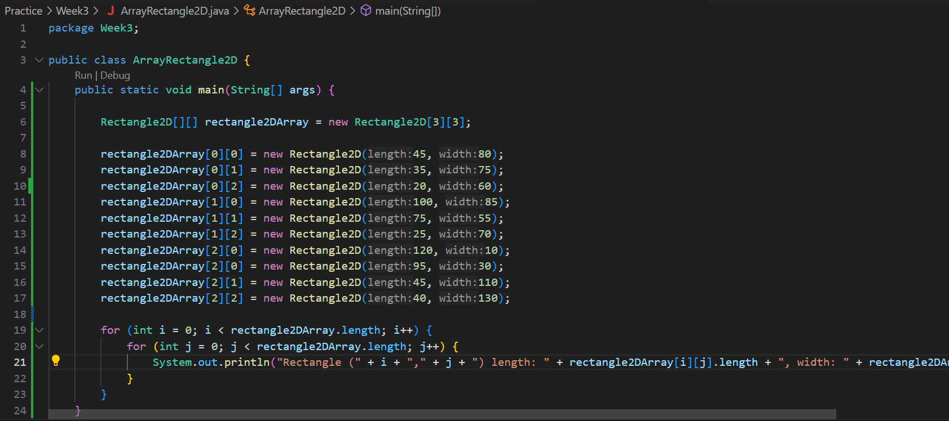

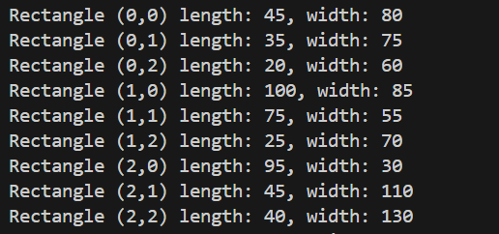

1. There is a **Square** class that has an attribute **side** with integer as its data type. There will be an error when we run this code, why?



Answer: There will be an error when we run this code because it did not have instantiation. If we want to run the code, we must create the instantiation first. squareArray[5] = new Square();

1. Modify the code on part 1.3 so that the length of the array will be defined from user input.

Answer:

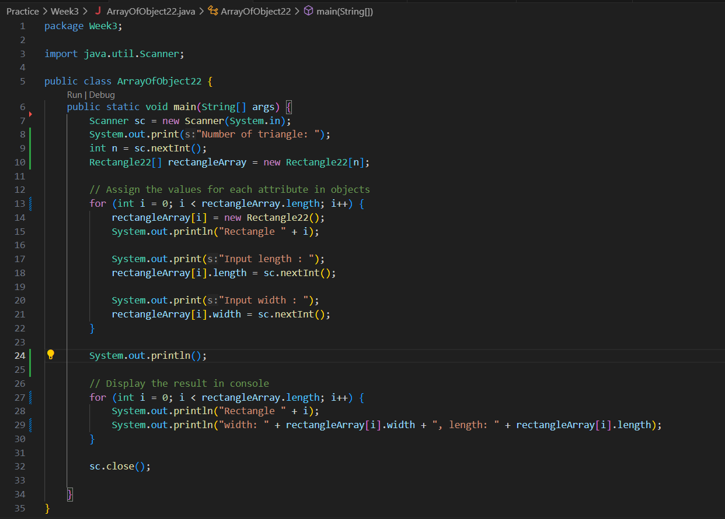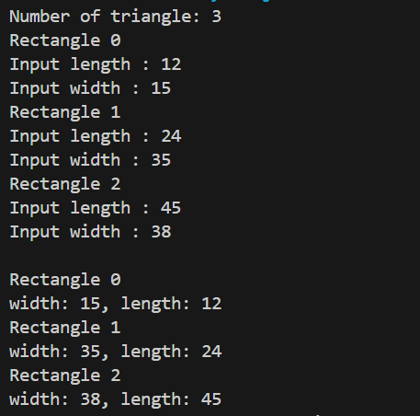

1. Can we duplicate the instantiation process in array of objects? For example, we assign the object in **ppArray[i]** and **ppArray[0]**, the instantiation process of **ppArray[0]** will be done twice. What’s the effect of this?

Answer: No, we cannot duplicate it. When assign the same object to two different indices in an array, the instantiation process will not be repeated.

**Lab Activity 3: Mathematical operation in array of object’s attribute**

**Result**

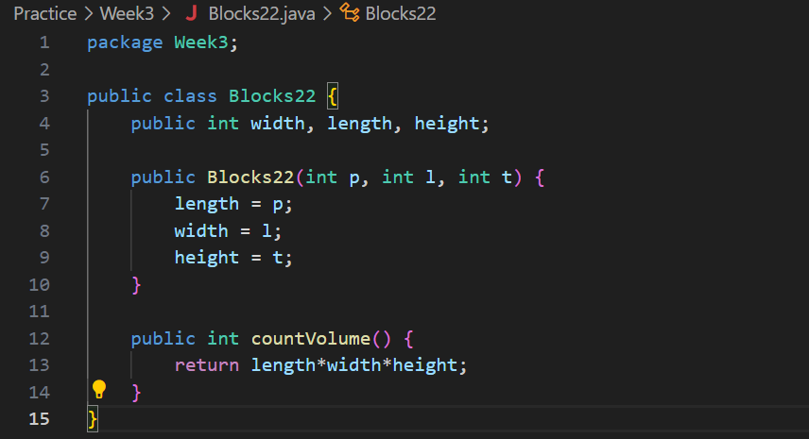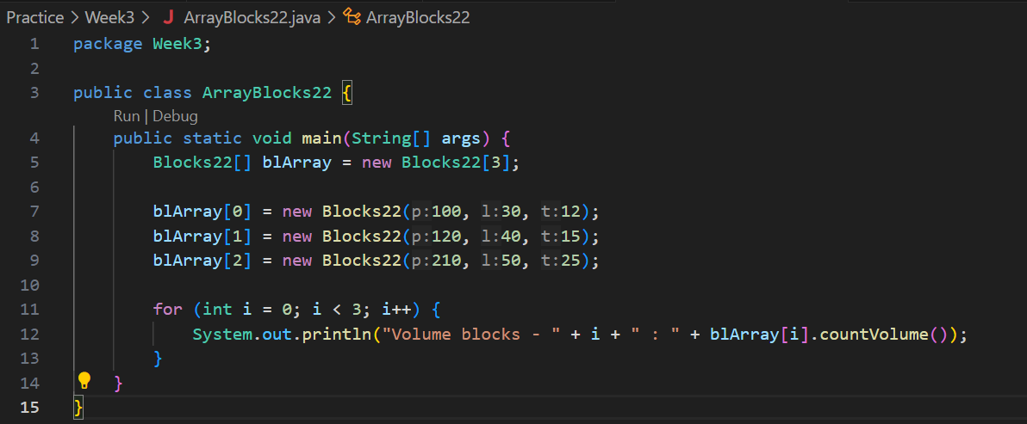

**Question**

1. Can we have more than one constructor in one class? Please explain.

Answer: Yes, we can have more than one constructor in one class, for example constructor with parameters and constructor without parameter

1. Create a **Triangle** class as follows.



Add another constructor in this class that has parameter int a, int t. These represents its base and height.

Answer:

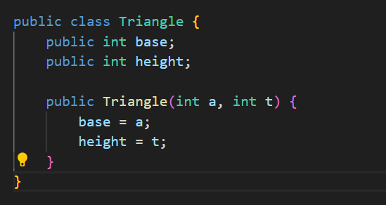

1. Add method **countArea()** and **countPerimeter()** in class Triangle

Answer:

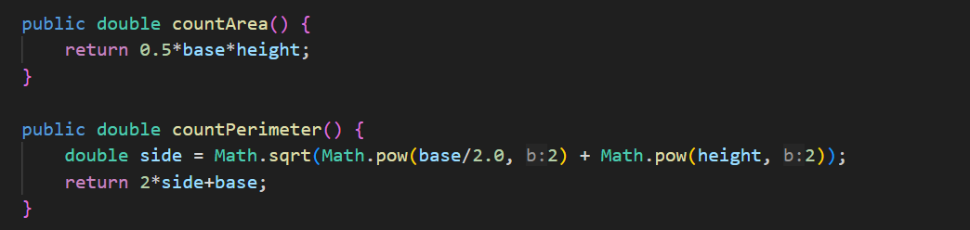

1. In main function, instantiate array of **Triangle** objects. Assign the attributes values as follows:

0th trArray base: 10, height: 4

1st trArray base: 20, height: 10

2nd trArray base: 15, height: 6

3rd trArray base: 25, height: 10

Answer:

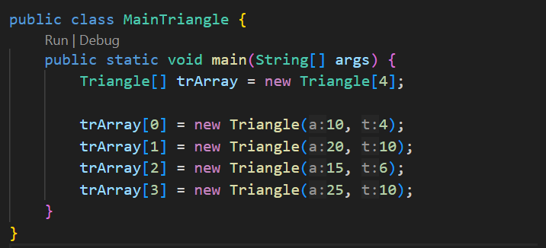

1. Display the result of area and perimeter for each triangle by calling the method **countArea()** and **countPerimeter()**

Answer:

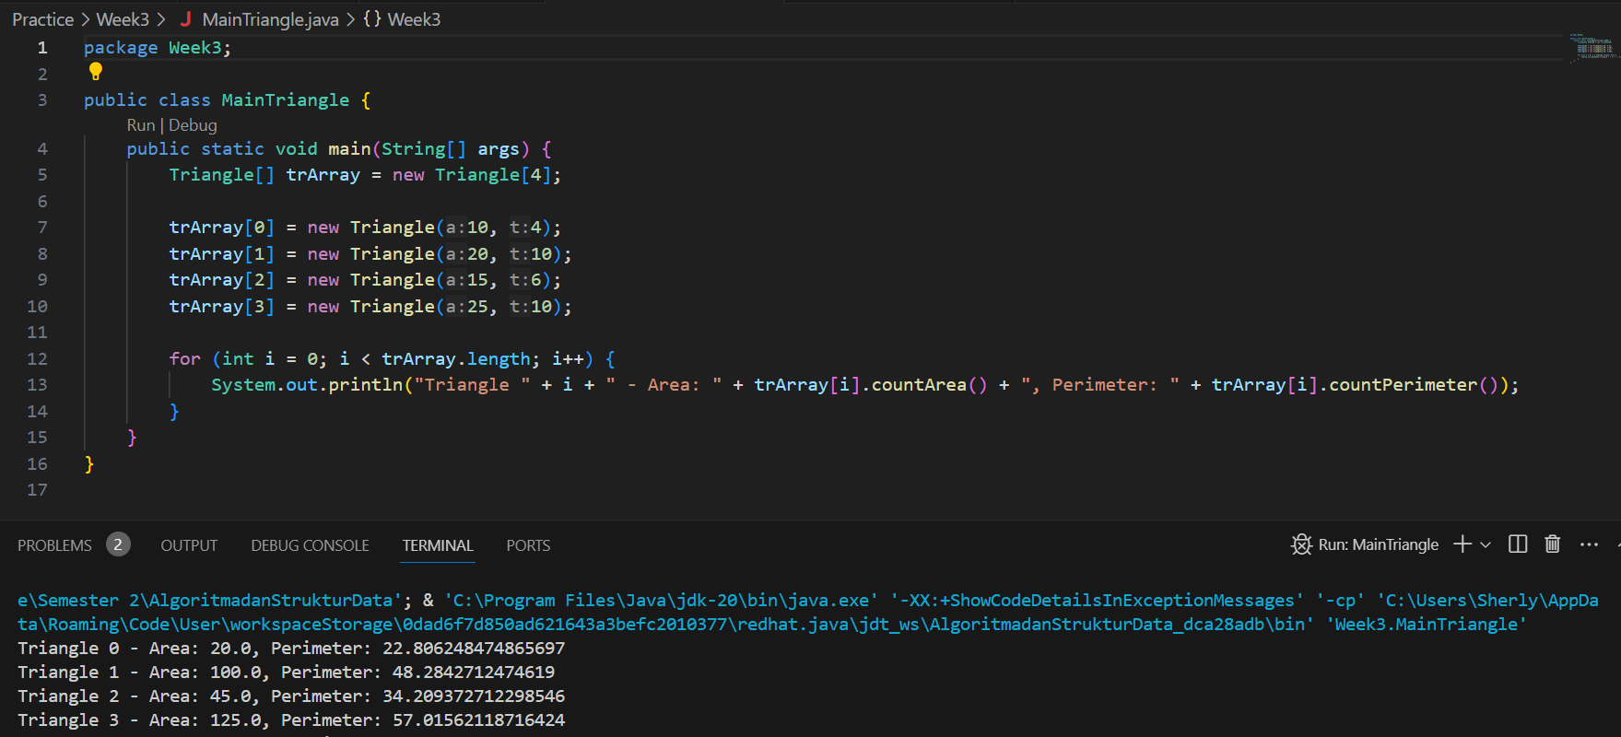

**Assignment**

1. Create a program that can calculate the **surface area** and **volume** of a **square pyramid**, and **sphere**. Create 3 (three) classes corresponding to each shape. Create one main class to create an array of objects that inputs the attributes using constructors for all these spatial shapes. With the following provisions:
2. Create a loop to input each attribute, then display the surface area and volume of each type of spatial shape.

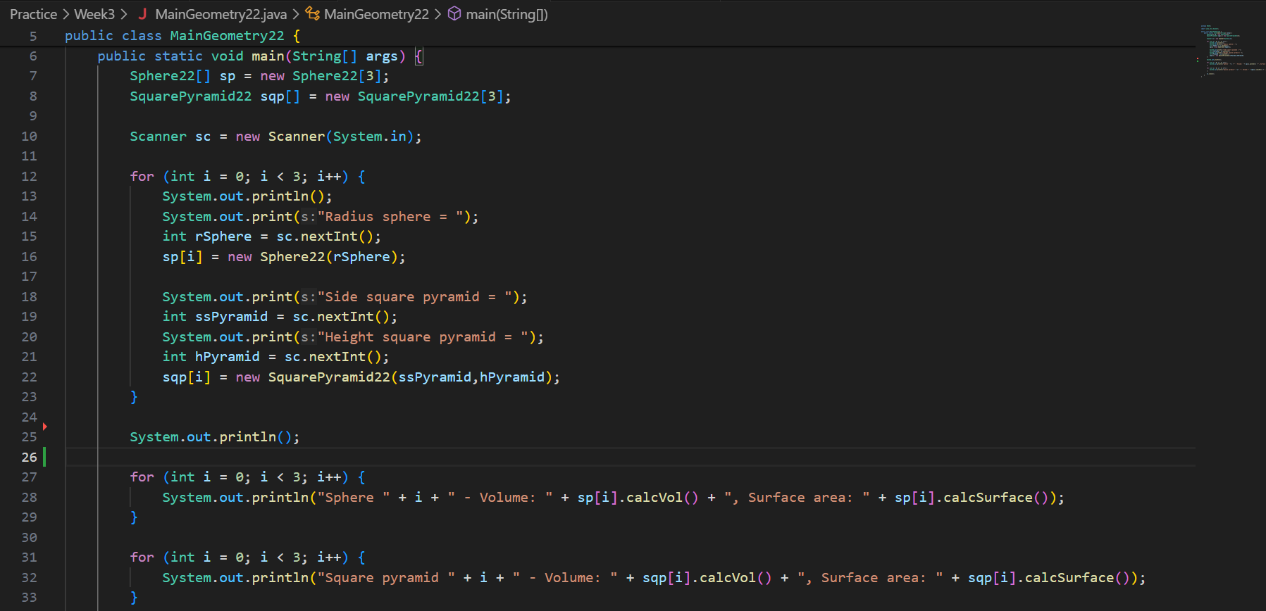

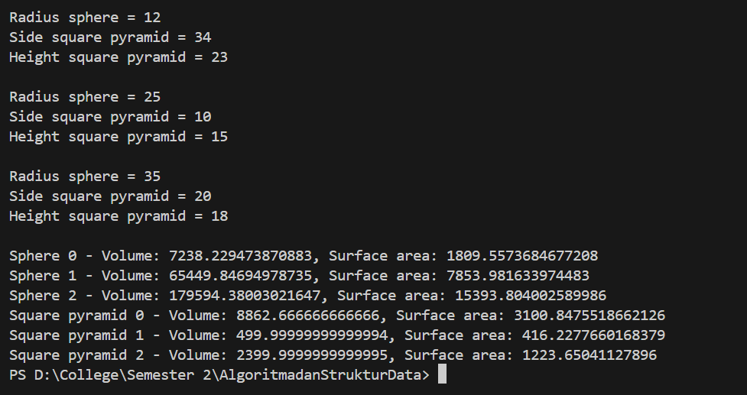

1. For the square pyramid, the input for attributes is only the length of the base side and the height of the pyramid.

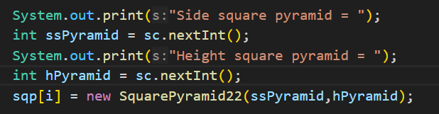

1. For the sphere, the input for attributes is only the radius.

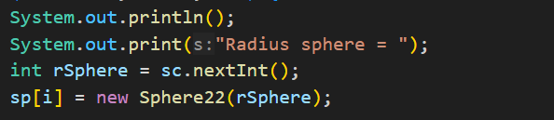

1. A university needs a program to display student’s information such as name, nim, gender, and GPA. This program should be able to receive input from all of those informations and display it to the user. Implement the program if there is 3 data sample, here is a reference of how you do it:

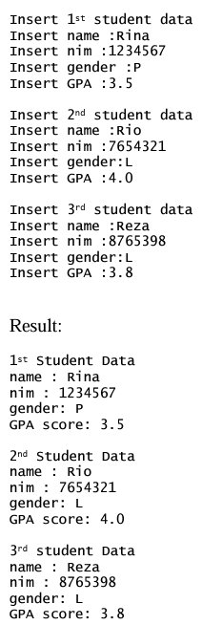

Answer:

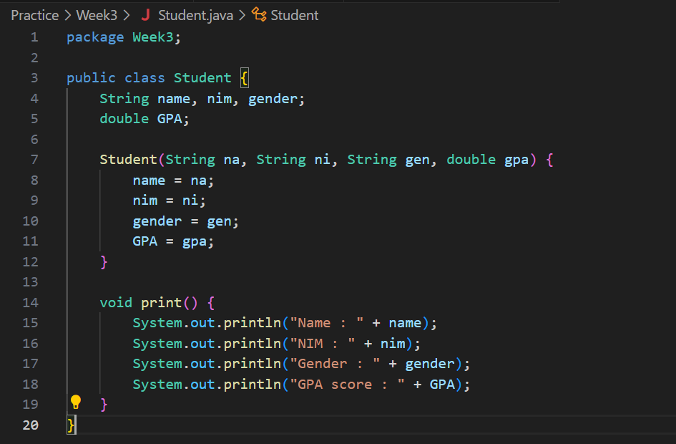

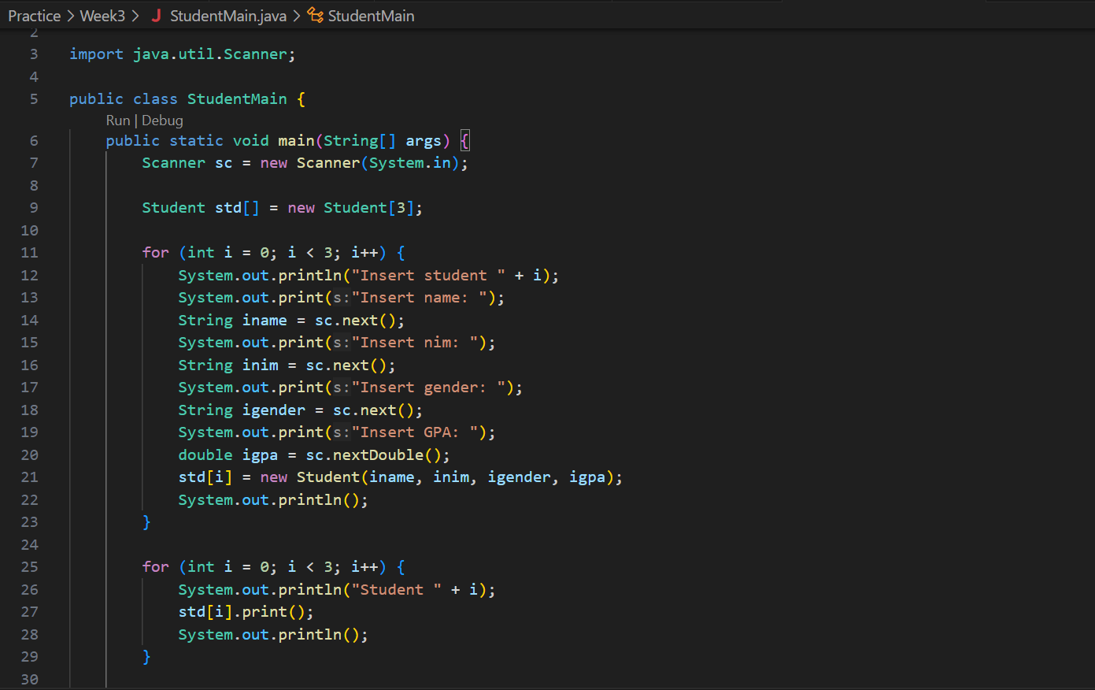

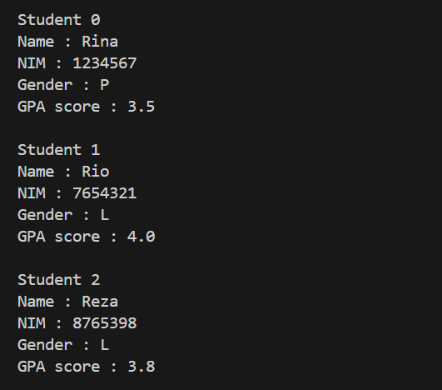

1. Modify the resulting program at no.2, so that it could be used to calculate Average GPA, as well as to display student information that has biggest GPA! (use method to implement each process)